WHAT IS SERVICENOW?

>> In order to answer “what”, first we need to know about the “who”, “when”, “why”, “how” & “where”.

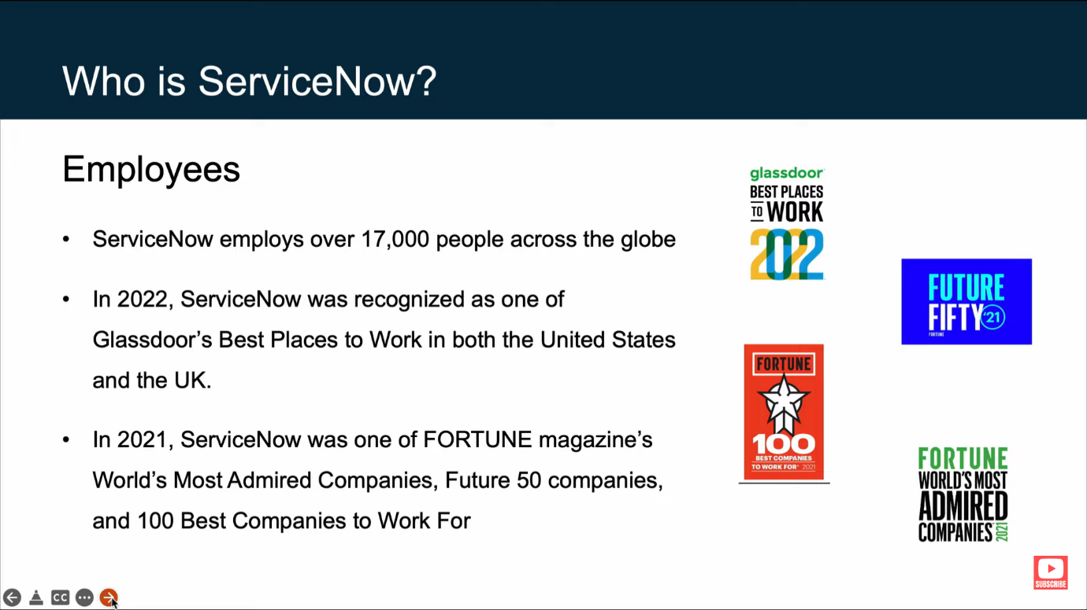

* ServiceNow’s current CEO is Bill McDermott.
* ServiceNow’s founder and current board chairman is Fred Luddy.

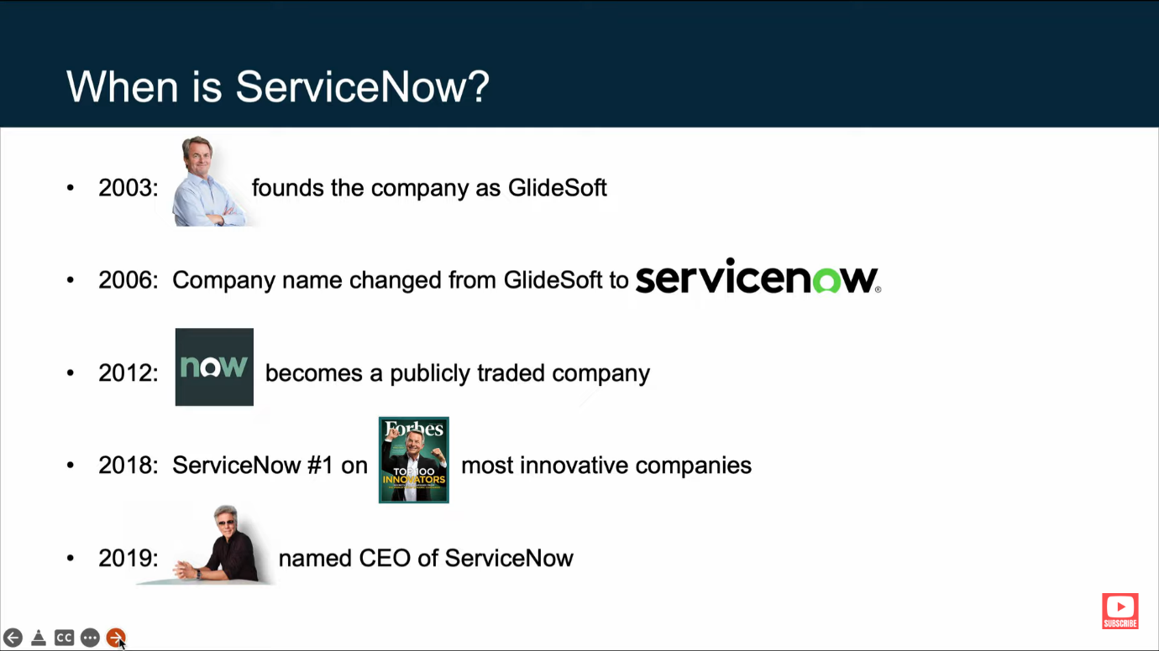

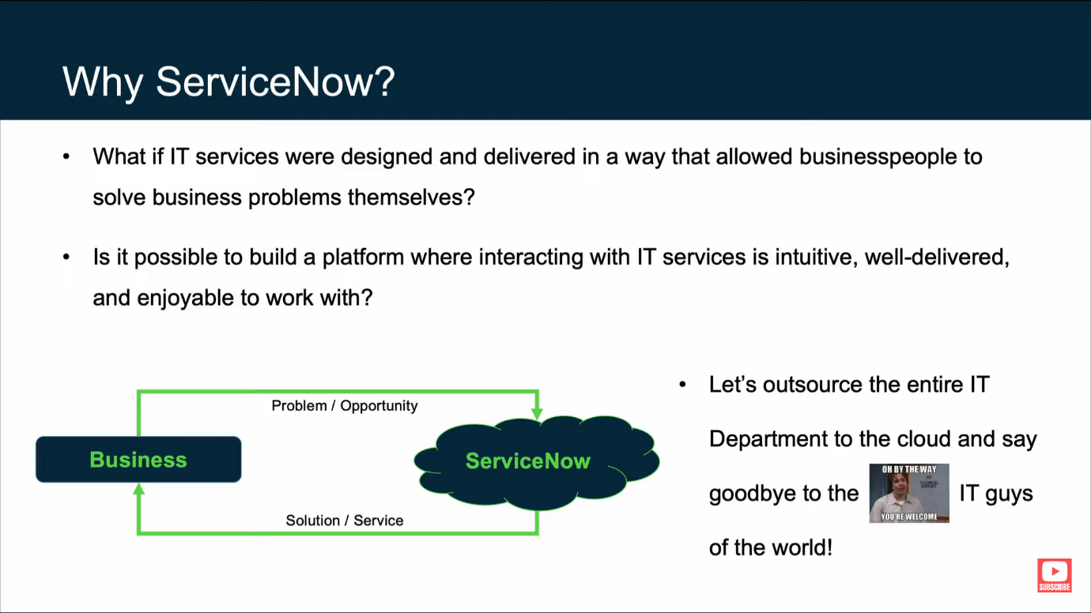

Over the course of his career, Fred Luddy had witnessed countless situations where information technology, its employees, and processes made smart businesspeople feel embarrassed and ignorant.

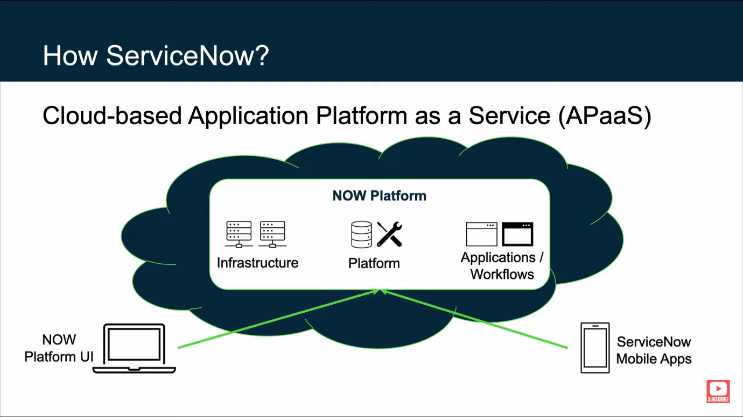

Infrastructure

* Computer resources: datacenteres, racks, servers, ports etc.
* Security: The platform is secured via multiple technologies which have been certified by third-party security organizations.
* Service level agreements: paired datacenteres provide redundancy and failover.
* Backups: 4 daily full backups per week.

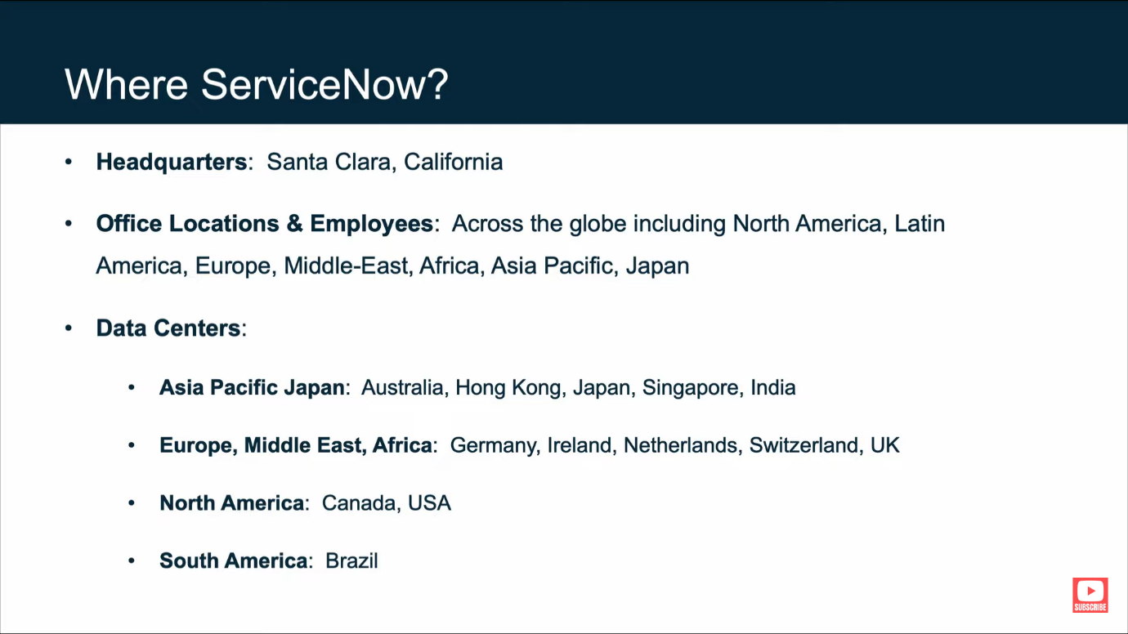

Finally, we can answer that what is ServiceNow as we have got quite a knowledge about it.

ServiceNow is a software company based in Santa Clara, California, founded by Fred Luddy in 2003, to solve problems large enterprises face with traditional IT delivery by providing a robust, simple to use, cloud-based environment in which businesspeople can solve the business problems themselves.

ServiceNow Platform Overview

>>The now platform

The now platform is an application platform as a service (APaaS)

* ServiceNow is a cloud-based.
* It provides a platform upon which you can develop your own custom solutions.
* It provides and supports the infrastructure computer resources.
* It provides a robust set of application and workflows to support most common business processes.
* All applications for the entire enterprise are supported by a single, common, data-model and database.

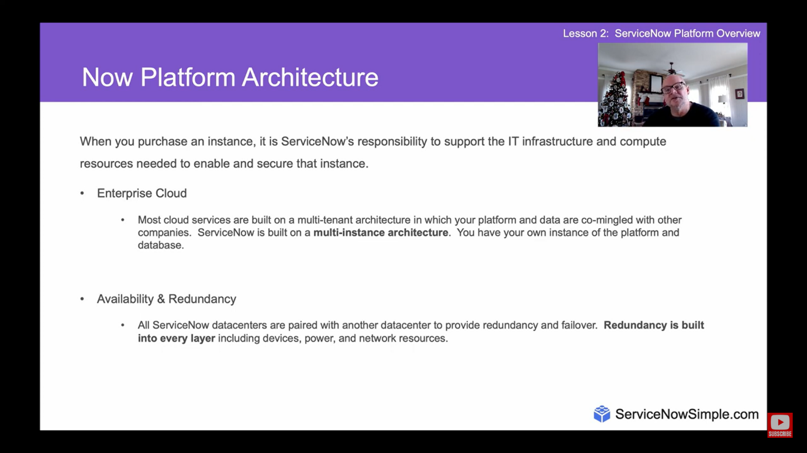

When you purchase an instance, it is ServiceNow’s responsibility to support the IT infrastructure and compute resources needed to enable and secure that instance.

* Backups & security
  + ServiceNow provides 4 weekly full data backups and 6 days of daily differential backups.
* Domain separation
  + The ServiceNow platform provides the ability to separate data, processes, and administrative tasks on an instance into logical groupings called domains.

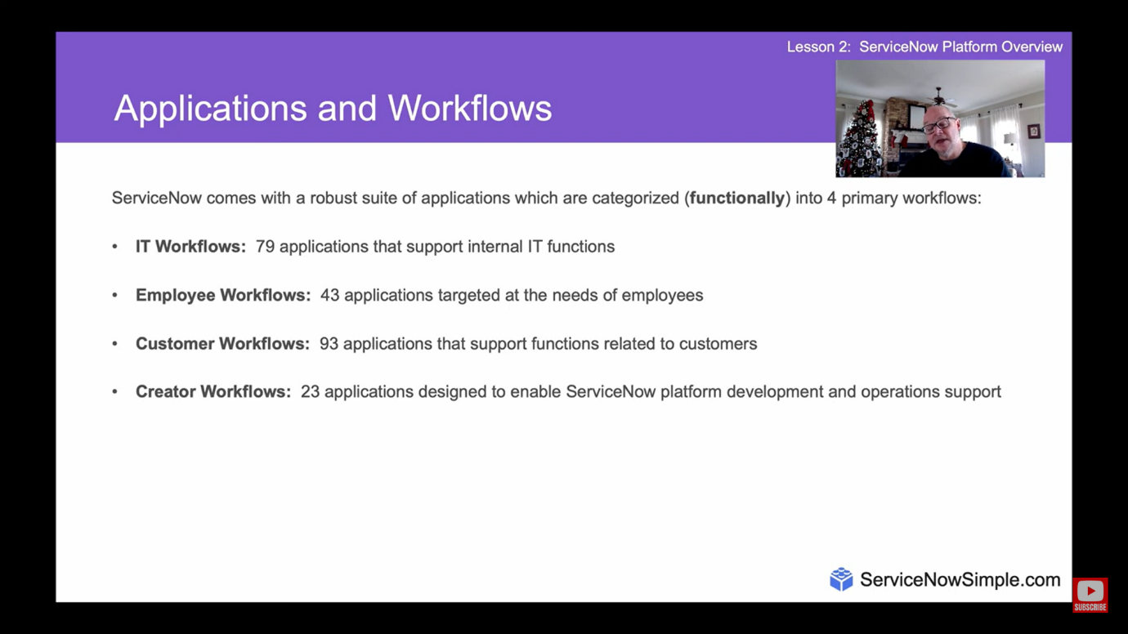

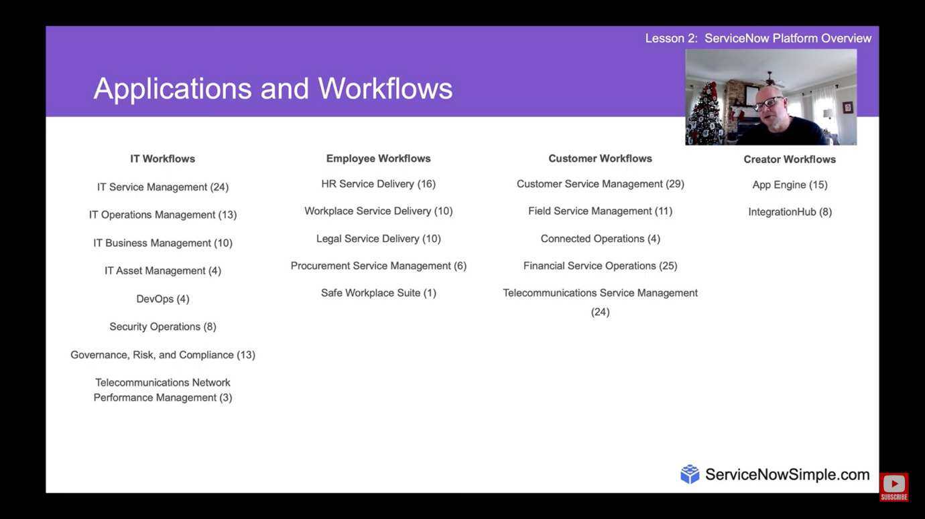

Now platform user-interfaces

ServiceNow provides 3 user-interfaces for interacting with the now platform.

* The Now platform UI is the primary UI. It is the best used on desktop and laptop computers and is accessed via web-browser and the instance URL.
* The ServiceNow mobile apps are best used on mobile devices and can be installed from the device’s app store.
* The Service portal is a user-friendly, self-service, widget-based portal accessed via web-browser and special URL.

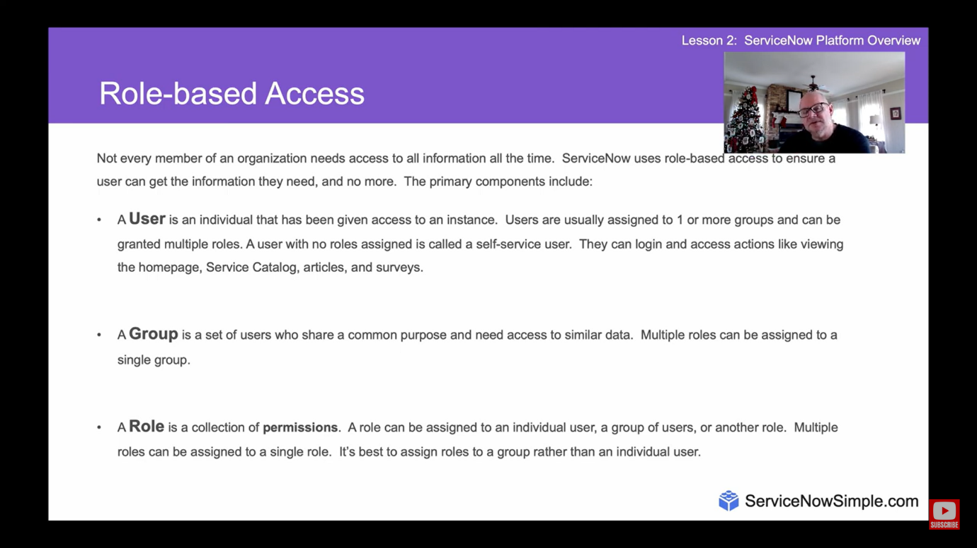

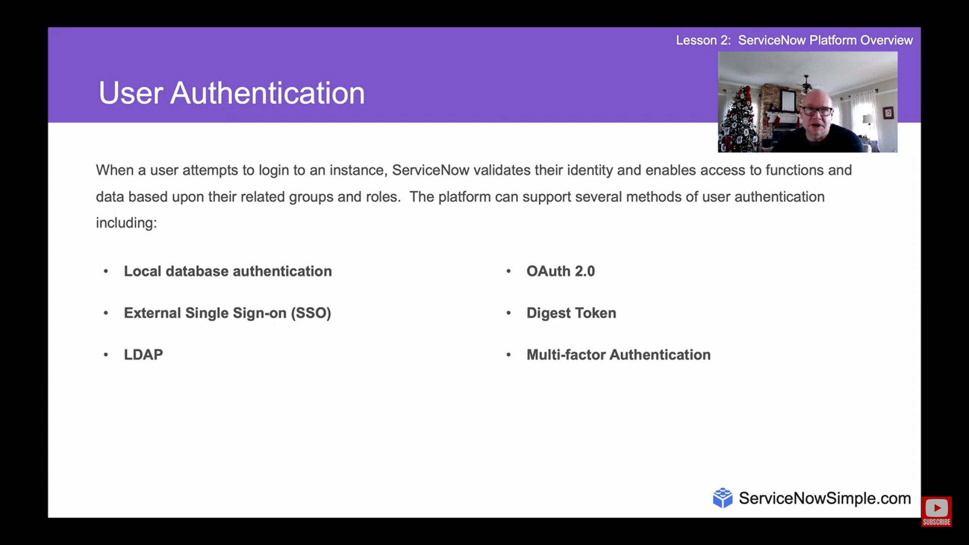

ServiceNow User Interface Overview

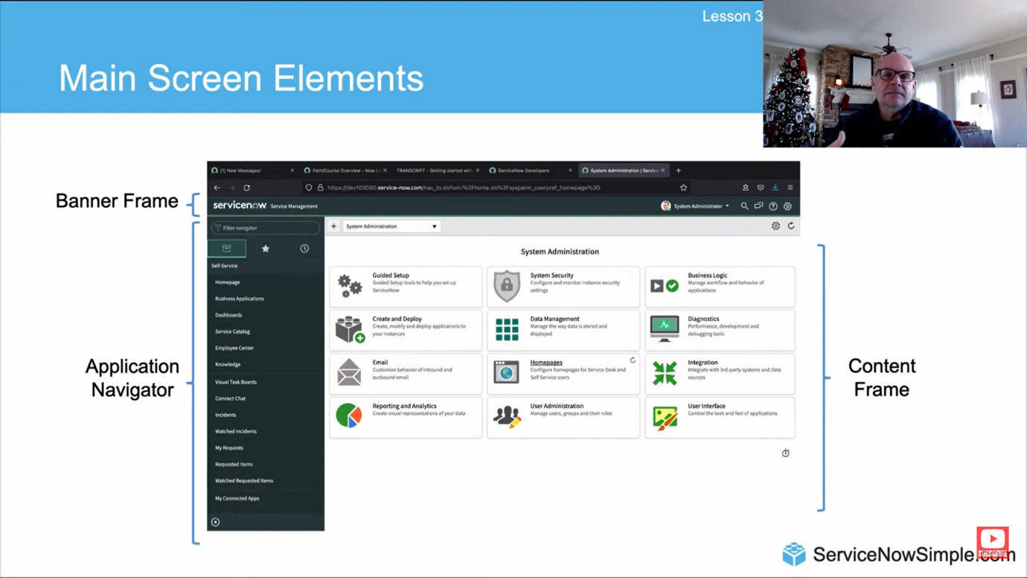

Banner Frame: User menu

The user menu provides the following tools:

* Profile: set profile attributes including name, phone, title, email, date format, time zone
* Impersonate user: access the instance as another user; available to users with admin or impersonator role
* Elevate roles: a safety mechanism for high-impact actions; available to system admin
* Logout: logout of the ServiceNow instance

Banner Frame: tools

Tools on the banner frame include:

* Global search: search the entire instance for records matching keywords
* Connect chats: ServiceNow’s real-time messaging tool
* Help: displays contextual help as available; a badge on the icon indicates embedded help is available; provides access to user guide; provides access to documentation search tool.

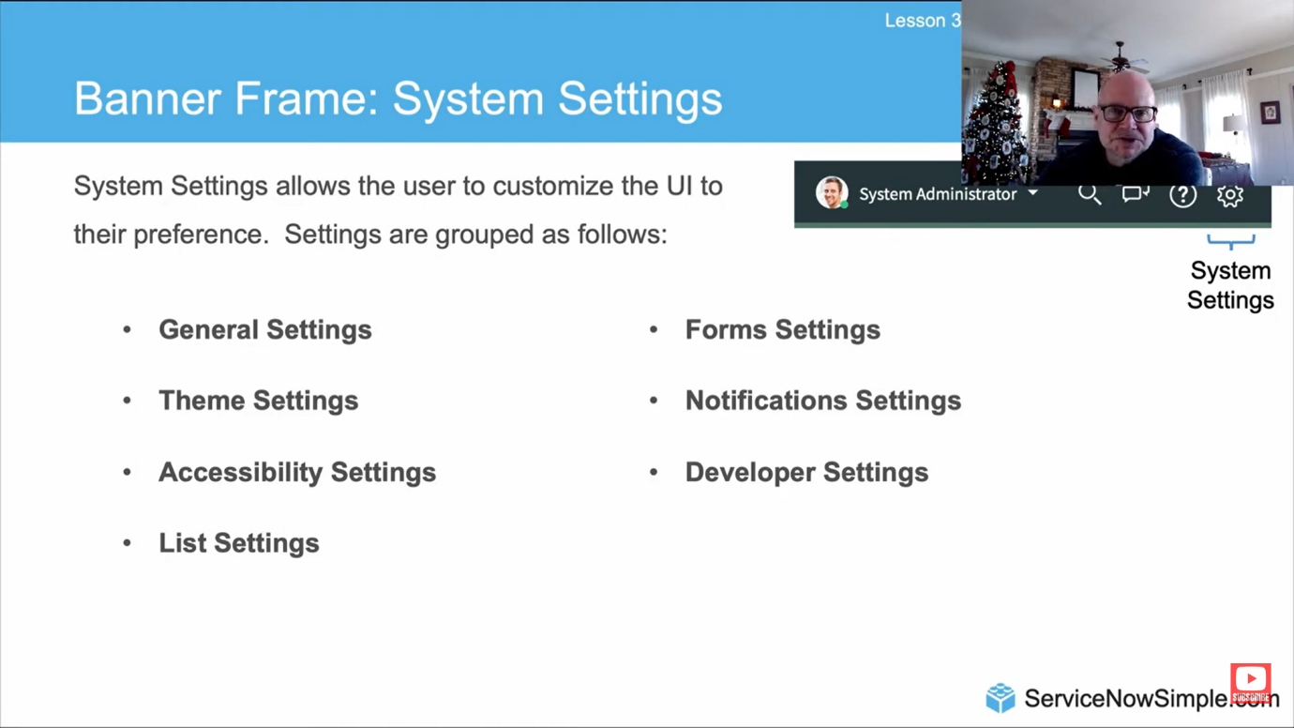

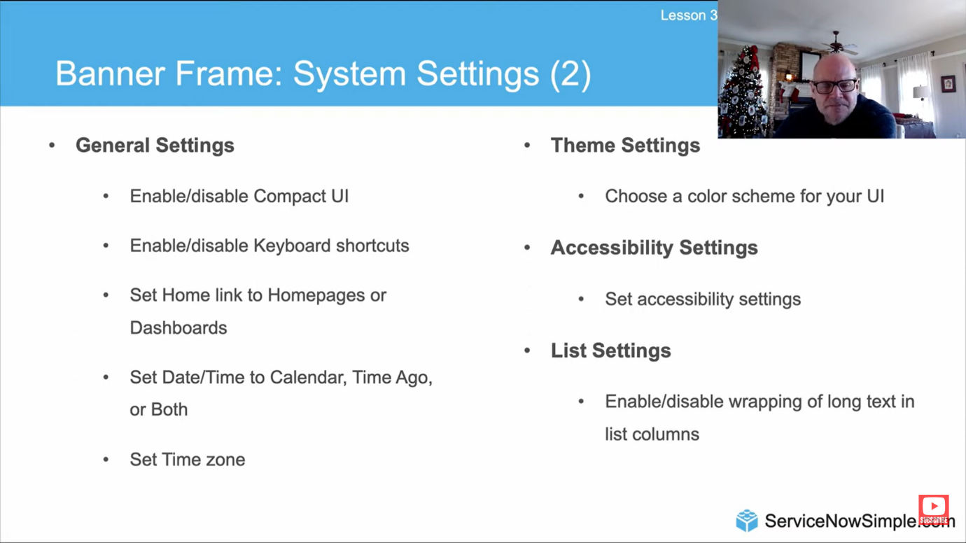

Other system settings that exist are:

* Form settings
* Developer settings
* Notification settings

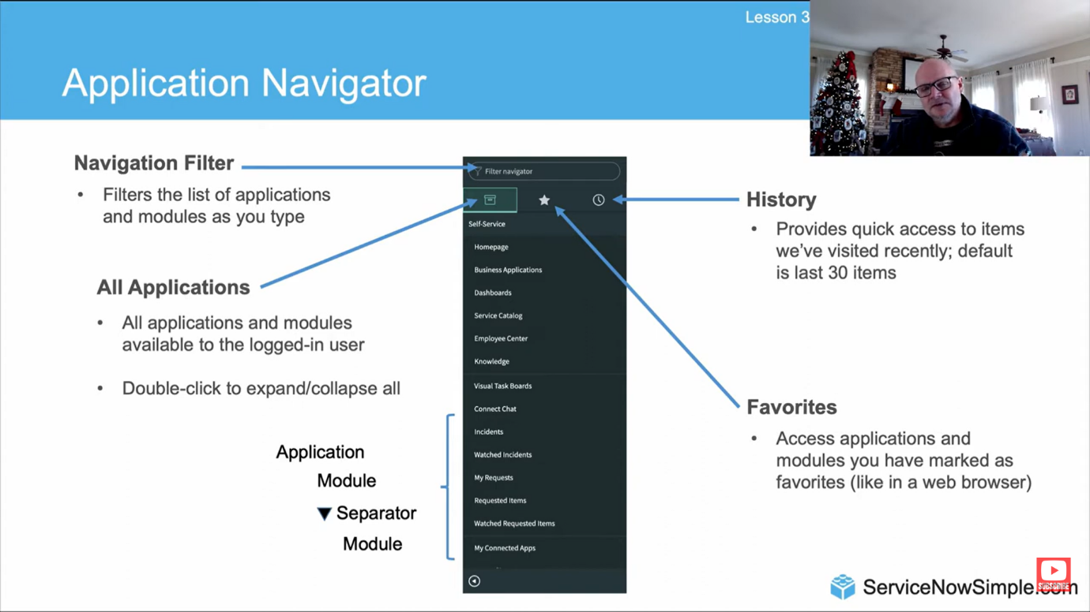

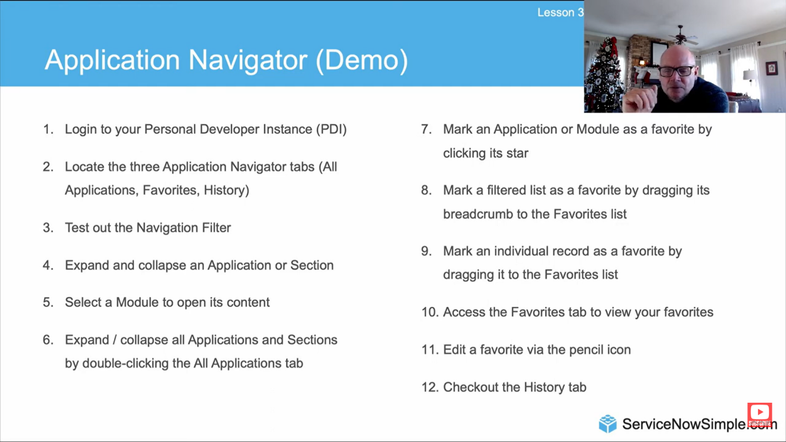

Further we will see the actual website and use of its various features and settings that help make the ServiceNow website very handy and useful.

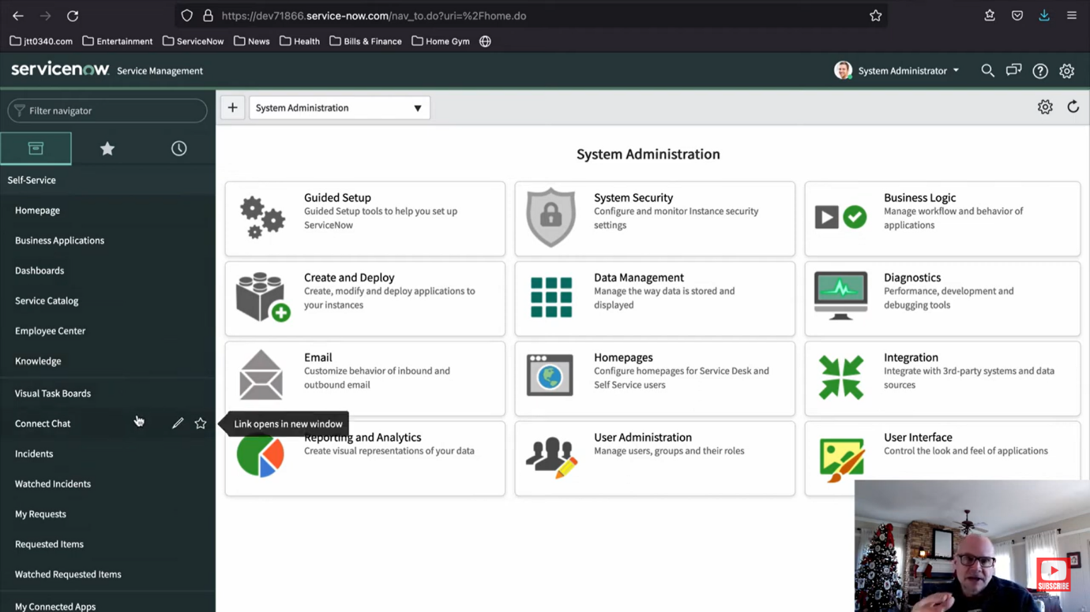

This is the homepage of ServiceNow service management web browser.

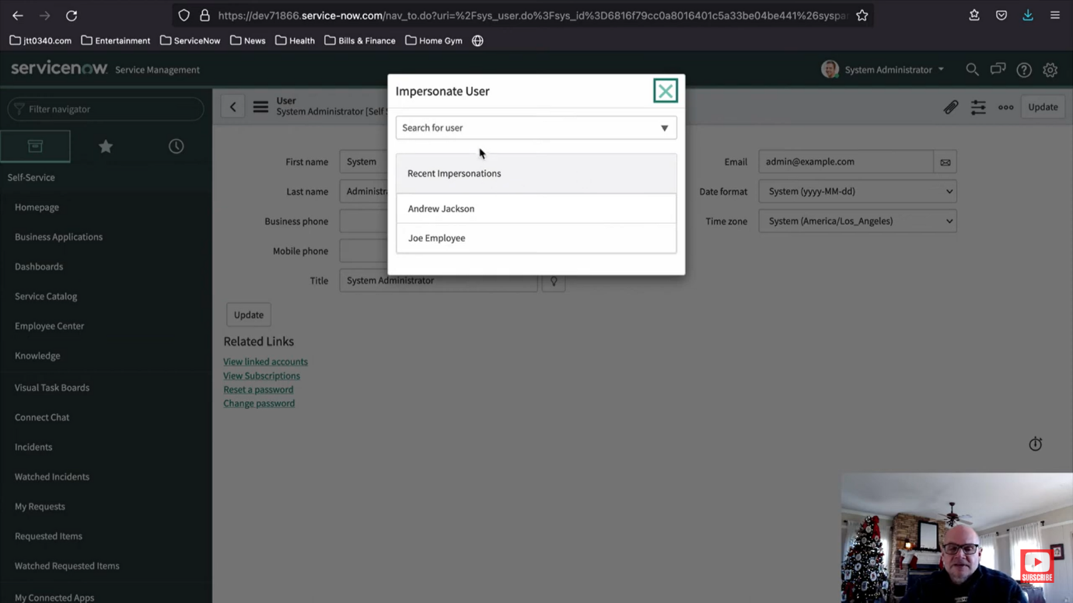

This is how we use impersonate user or elevate role using user profile. This also have options for log out.

This is a very simple and handy platform where ever feature is very useful and serves a specific purpose.

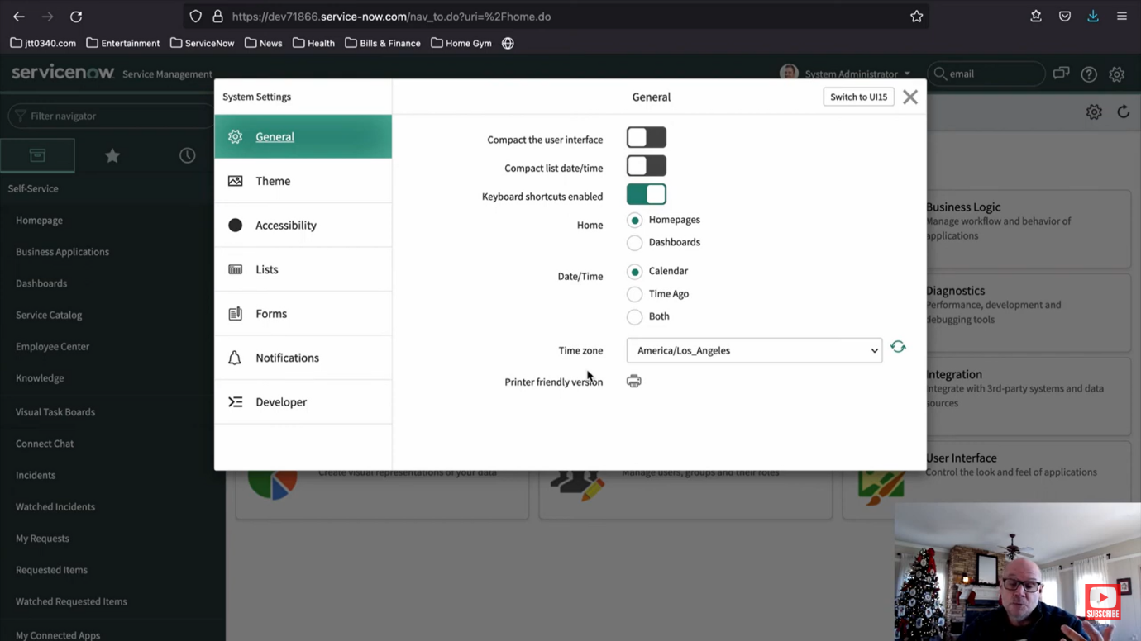

This pop-up helps to customize the platform by giving us various options in the field of general, theme, accessibility, lists, forms, notifications, developer

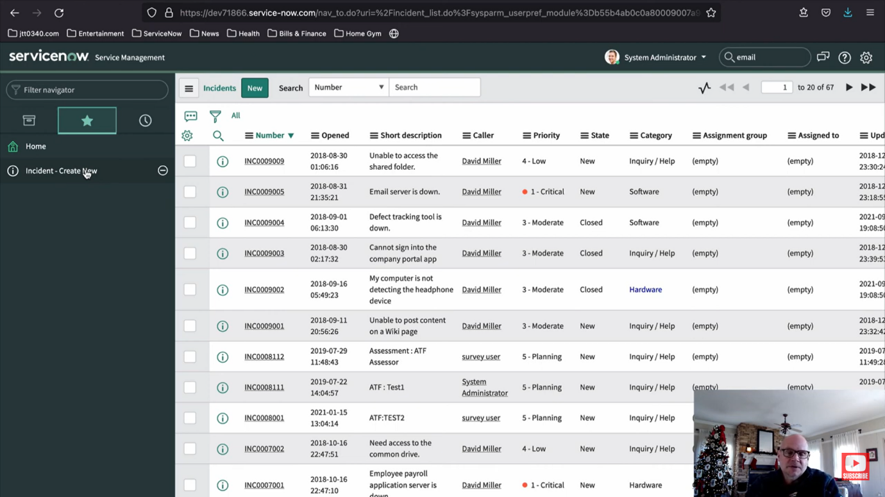

This shows the incident page here all the activity is recorded in the form of lists..this list has column (fields) and row (records).

We can create, remove, presonalize, filter, search, etc… the incident list according to our needs.

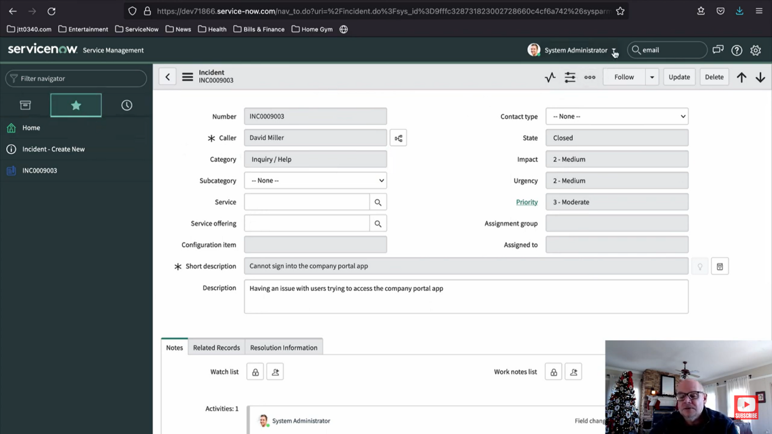

This is a form that is used to record data that is entered in the form. this is used to create various records in the ServiceNow platform .

ServiceNow Branding Overview

What is branding in ServiceNow?

Applying your distinct corporate identity across the now platform UI to create a shared identity, build trust, and speed adoption.

It is one of the many reasons to which this makes the developer portal of ServiceNow more useable.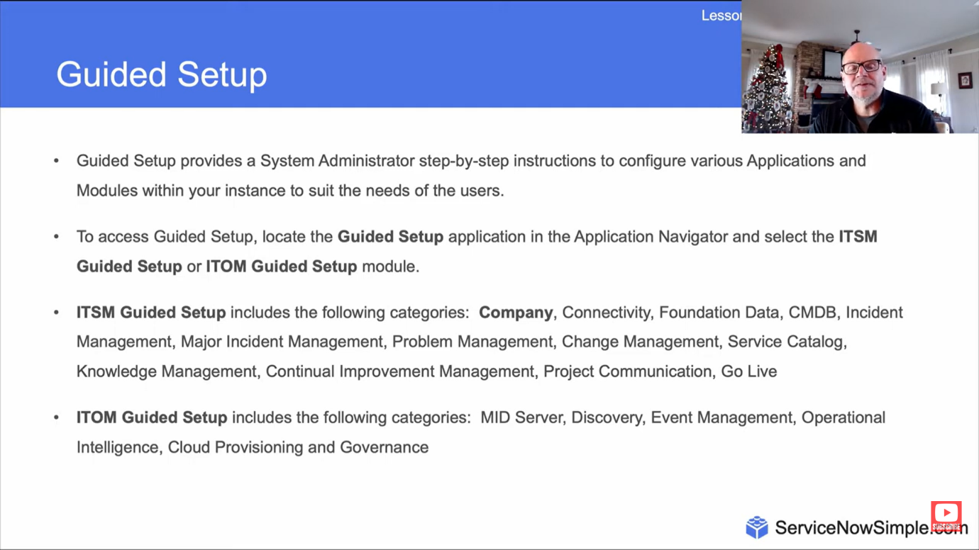

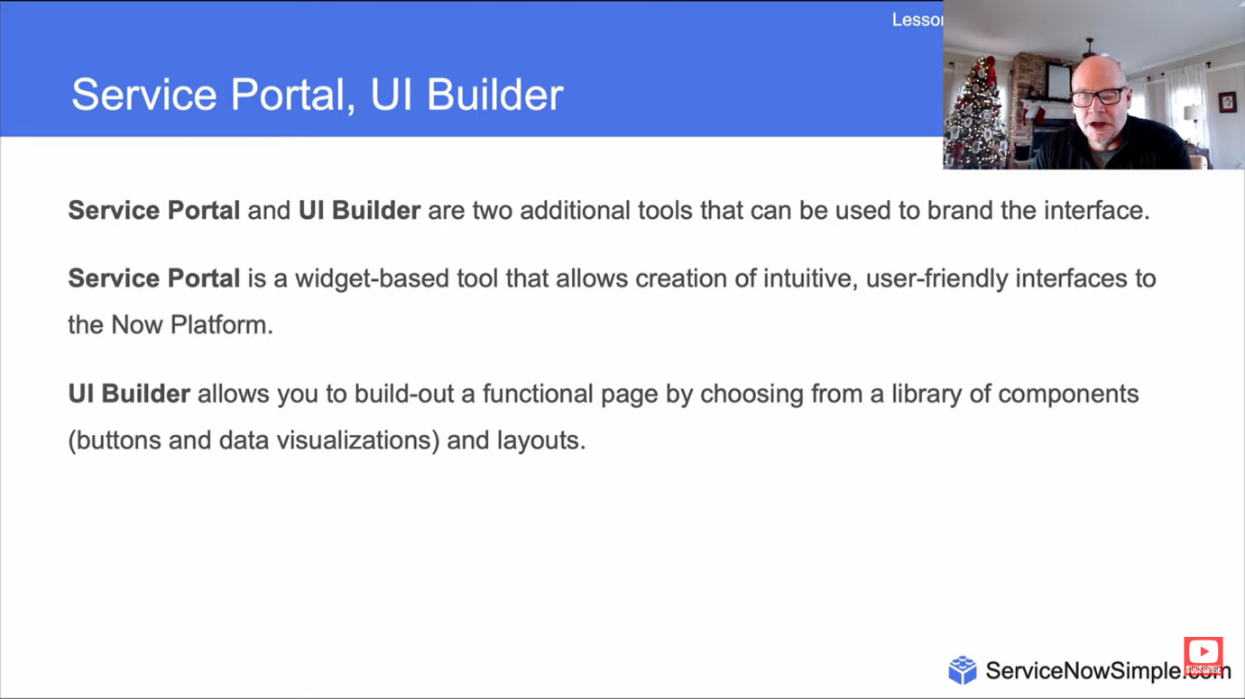

ServiceNow Lists and Filters

Here are some image of the list and its features and structure that is provided by the ServiceNow portal.

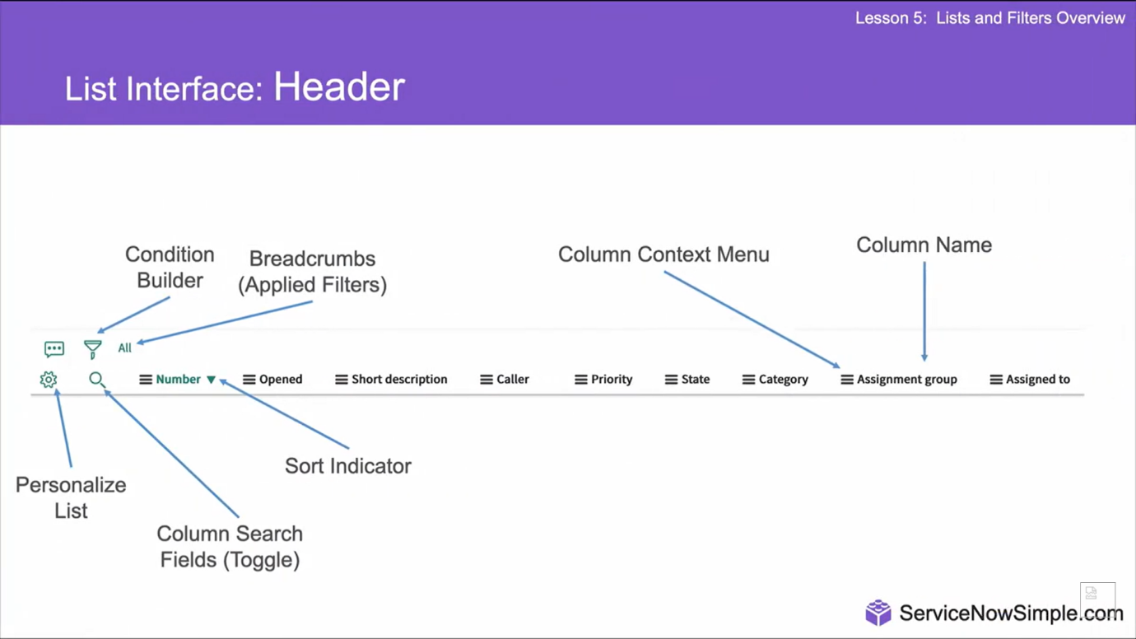

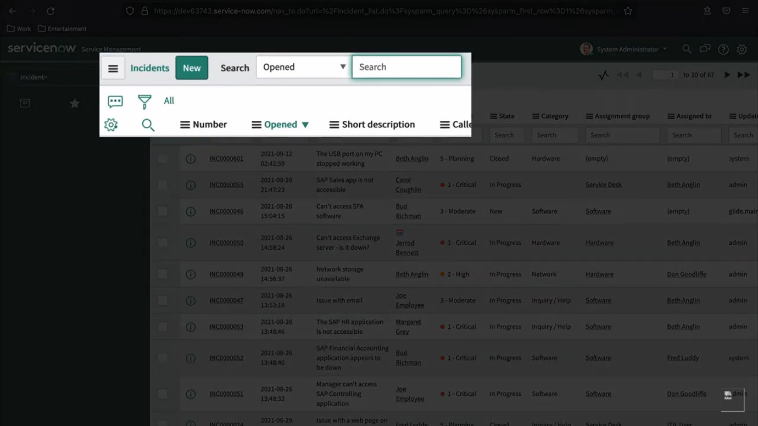

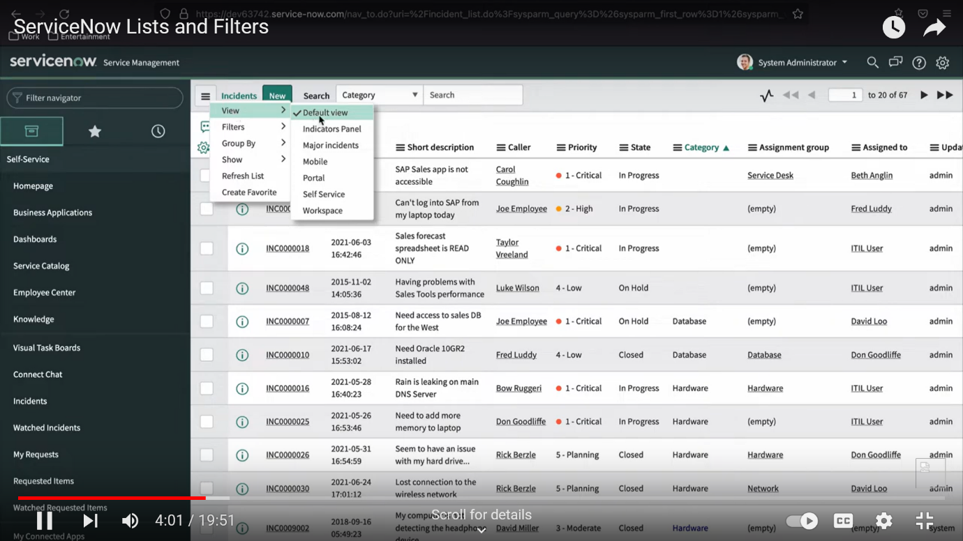

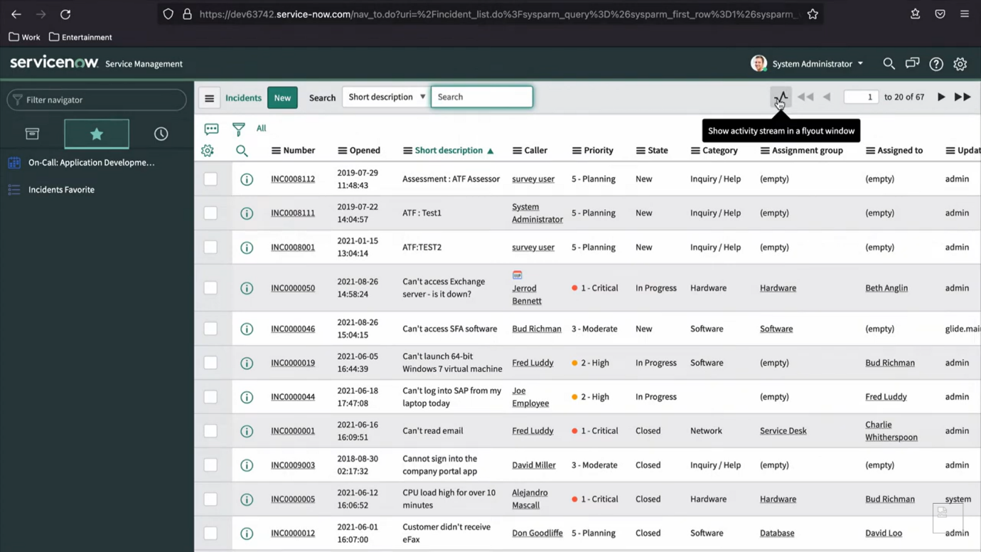

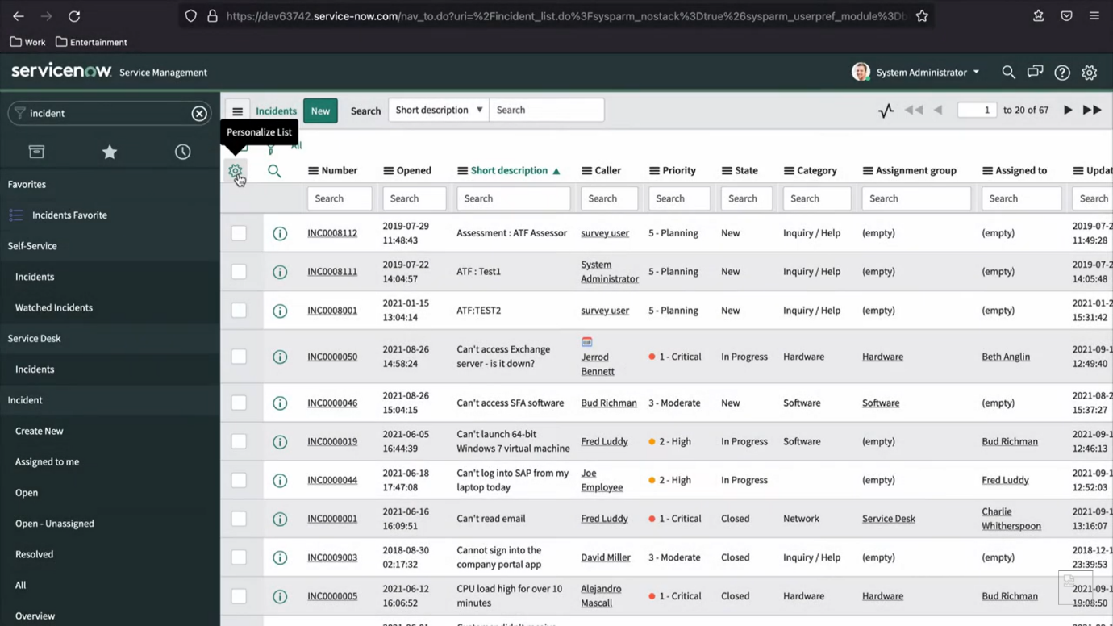

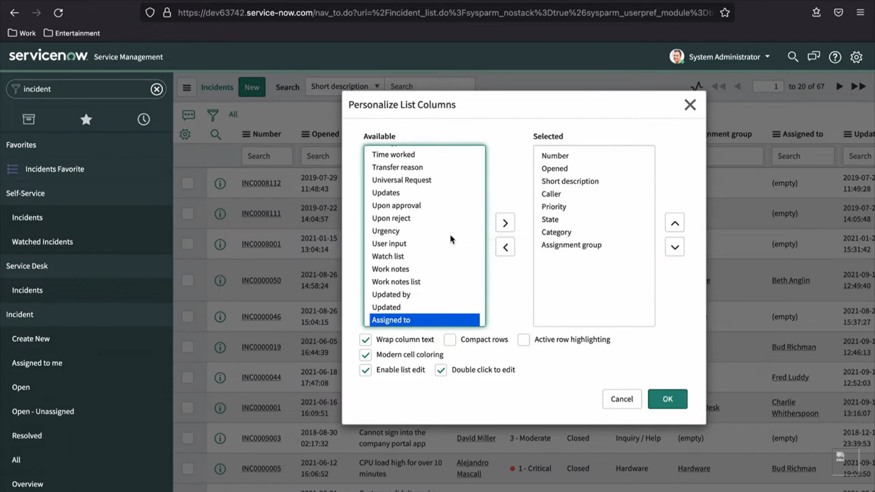

Forms in ServiceNow

Here is some of the understandings regarding the form in servicenow.

